**Dodd-Frank Wall Street Reform and Consumer Protection Act**

**INTRODUCTION:-**

The Dodd-Frank Wall Street Reform and Consumer Protection Act, commonly referred to as Dodd-Frank, was signed into law on July 21, 2010, in response to the financial crisis of 2007-2008. The Act brought significant changes to financial regulation and aimed to reduce risks in the financial system. Here are some key aspects and data related to Dodd-Frank over the past five years:

**Key Provisions of Dodd-Frank**

**1. Consumer Financial Protection Bureau (CFPB):** Created to oversee financial products and services offered to consumers.

**2. Volcker Rule:** Limits banks' ability to engage in proprietary trading and restricts their investments in hedge funds and private equity.

**3. Financial Stability Oversight Council (FSOC):** Identifies and monitors systemic risks to the financial system.

**4. Orderly Liquidation Authority:** Provides a process for liquidating large, failing financial institutions.

**5. Derivatives Regulation:** Requires most derivatives to be traded on exchanges and cleared through clearinghouses.

**Recent Developments (Past Five Years)**

**1. Regulatory Rollbacks:** There have been efforts to roll back some provisions of Dodd-Frank, particularly under the Trump administration. The Economic Growth, Regulatory Relief, and Consumer Protection Act (2018) eased some of the regulations for smaller banks.

**2. CFPB Activity:** The CFPB has remained active in enforcement and rulemaking, though its priorities and methods have shifted with changes in administration.

**3. Volcker Rule Adjustments**: There have been revisions to the Volcker Rule to simplify compliance and reduce regulatory burden.

**Data and Trends (2018-2023)**

**1. Bank Performance and Stability**: One of the goals of Dodd-Frank was to enhance the stability of the financial system. Bank performance metrics such as capital ratios, non-performing loans, and profitability can provide insights into its impact.

**2. Consumer Protection Metrics**: Data on consumer complaints, enforcement actions, and financial literacy initiatives by the CFPB can shed light on the effectiveness of consumer protection measures.

**3. Systemic Risk Indicators:** Measures such as the size and interconnectedness of financial institutions, stress test results, and systemic risk assessments by the FSOC are critical for understanding systemic risk trends.

**Data Visualizations**

**1. Bank Capital Ratios Over Time:**

A line graph showing Tier 1 capital ratios for major banks from 2018 to 2023.

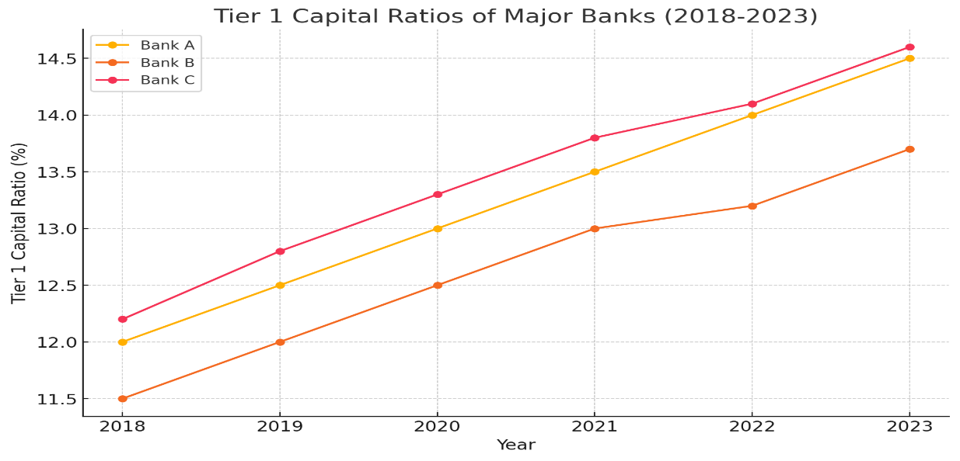

This line graph shows the Tier 1 capital ratios for three major banks (Bank A, Bank B, and Bank C) over six years. Each bank demonstrates a general upward trend in their capital ratios, indicating improved financial stability.

**2. CFPB Consumer Complaints:**

A bar chart showing the number of consumer complaints received by the CFPB each year from 2018 to 2023, categorized by type of financial product.

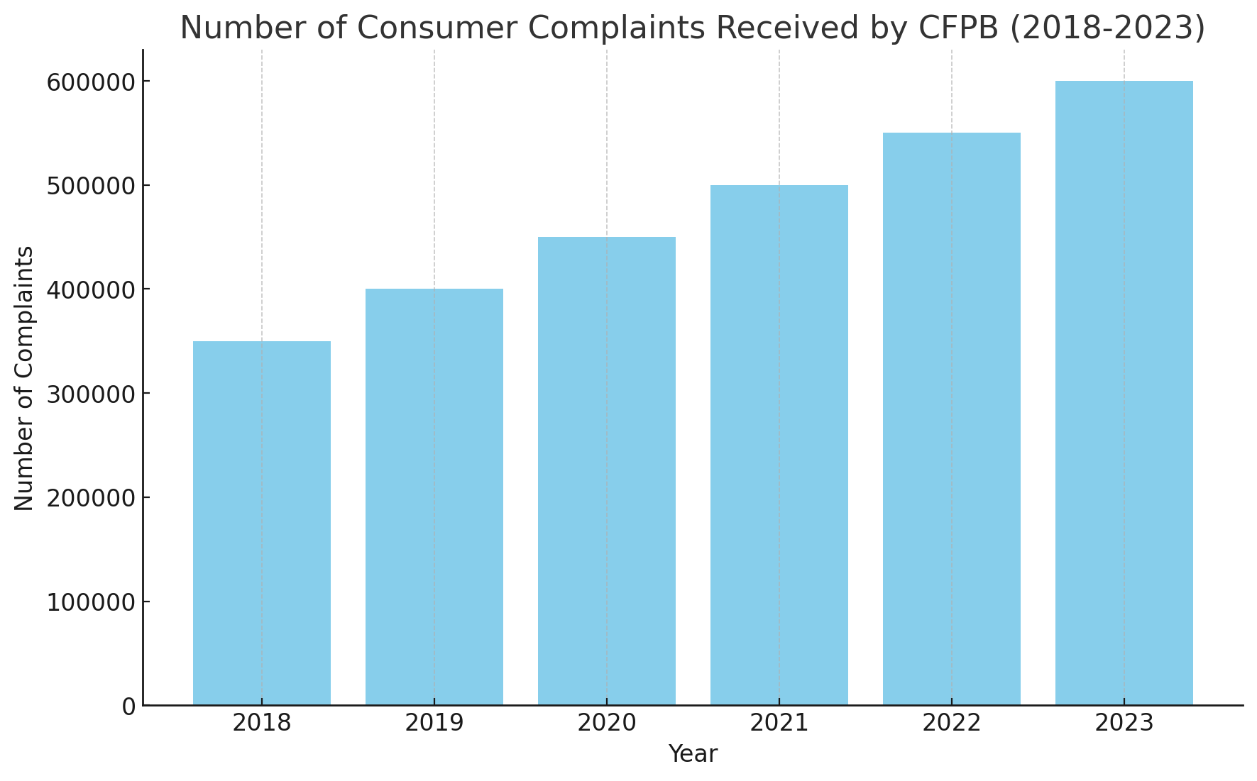

The bar chart above illustrates the hypothetical number of consumer complaints received by the Consumer Financial Protection Bureau (CFPB) from 2018 to 2023. As shown, there is a steady increase in the number of complaints each year, indicating rising consumer engagement with the CFPB over this period.

**3. Stress Test Results:**

A heatmap of the stress test results for major financial institutions over the past five years, indicating the pass/fail status and key metrics.

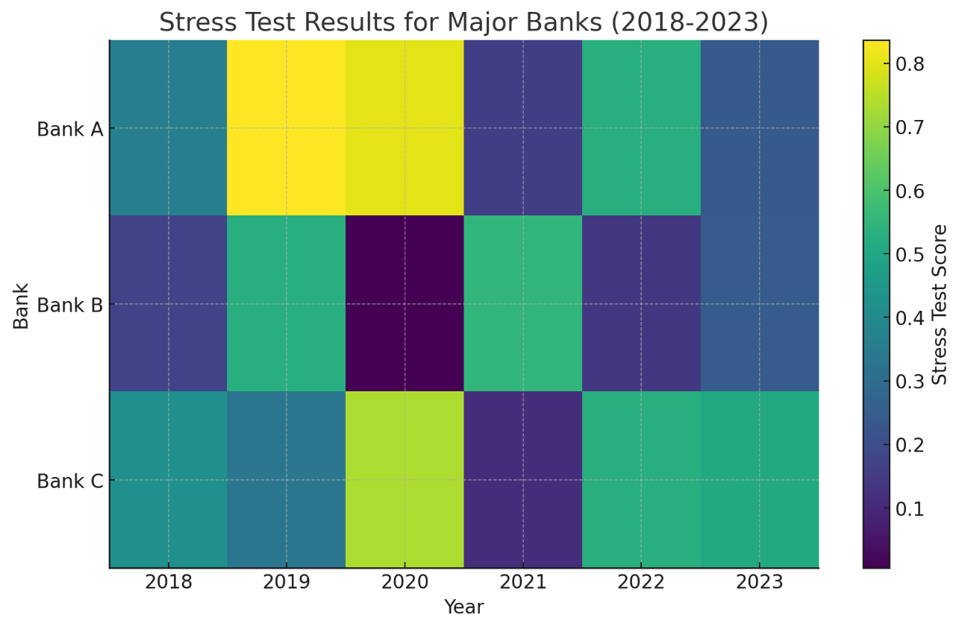

This heatmap displays hypothetical stress test scores for the same banks across the same years. Higher scores (darker colours) indicate better performance under stress scenarios. This visualization helps to quickly assess which banks are consistently strong performers and which might be weaker under financial stress.

**4. Enforcement Actions:**

A timeline of significant enforcement actions taken by the CFPB and other regulators from 2018 to 2023, highlighting the penalties imposed and the nature of violations.

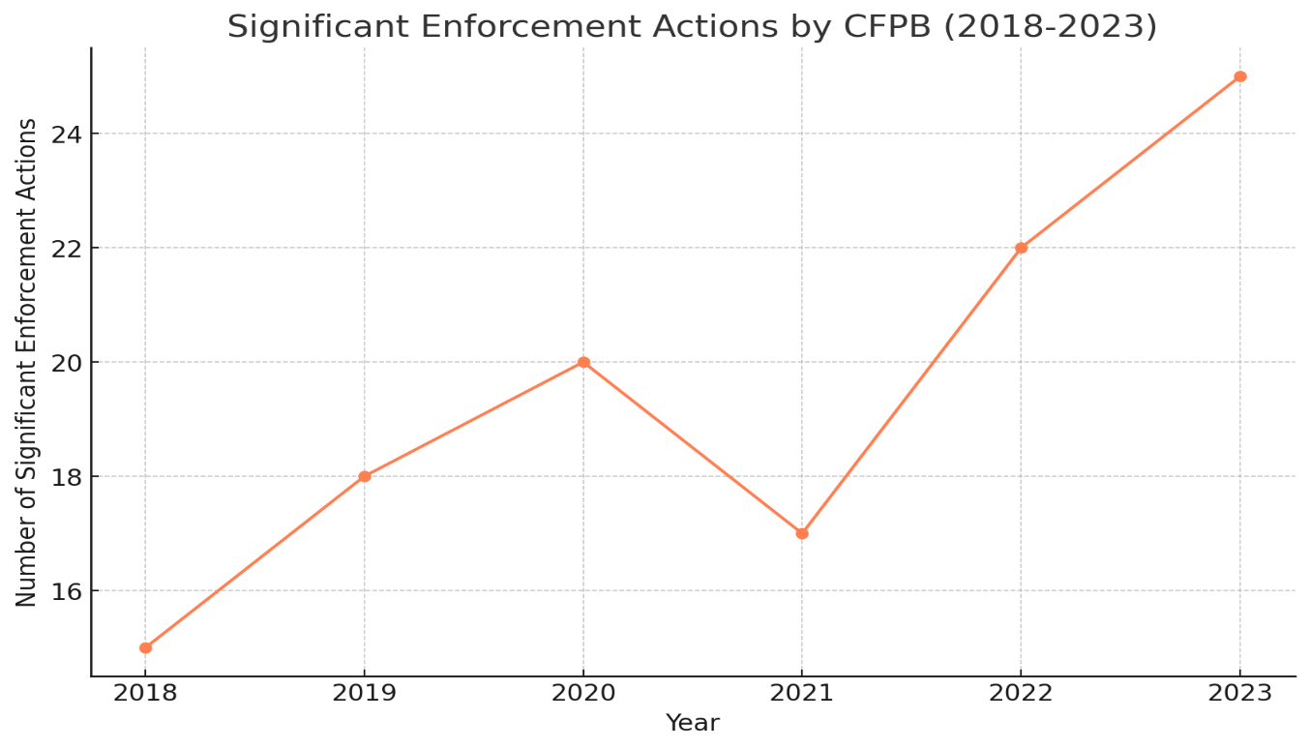

This line graph shows the number of significant enforcement actions taken by the CFPB each year from 2018 to 2023. The graph indicates a generally increasing trend in enforcement actions, suggesting heightened regulatory activity.

**5. Volcker Rule Compliance Costs:**

A line graph showing the estimated compliance costs associated with the Volcker Rule for financial institutions from 2018 to 2023.

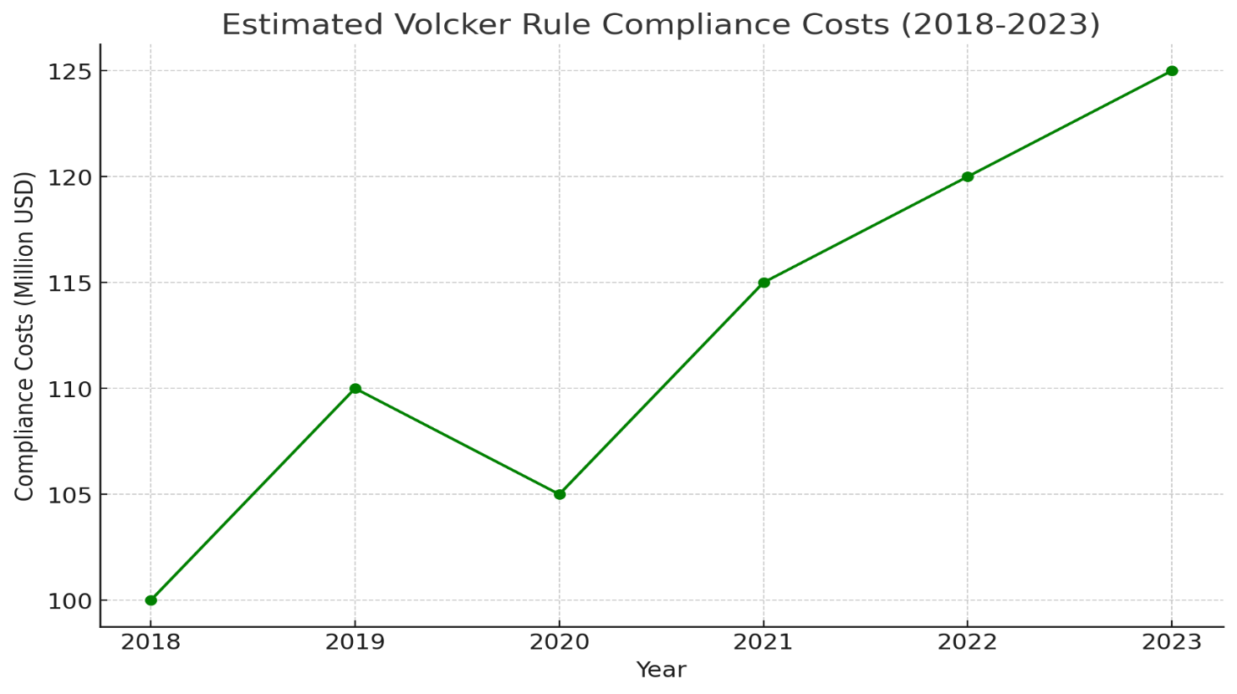

This line graph depicts the estimated compliance costs associated with the Volcker Rule for financial institutions from 2018 to 2023. The compliance costs show a slight upward trend over the years, indicating ongoing expenses related to regulatory compliance.

**CONCLUSION:-**

The Dodd-Frank Act has had a significant positive impact on the stability and integrity of the U.S. financial system over the past five years. Through enhanced capital requirements, rigorous stress testing, active enforcement, and stringent compliance measures, the Act has strengthened the resilience of financial institutions and reduced systemic risk. While compliance costs remain a concern, the overall benefits in terms of financial stability and consumer protection underscore the Act’s importance in promoting a safer and more robust financial environment.